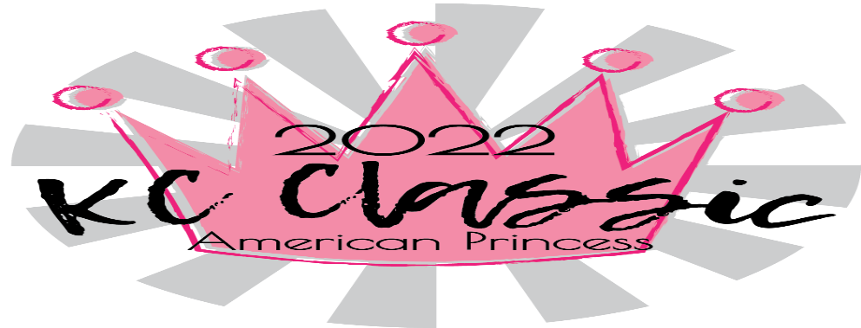
USAG Entry Form -- January 7th-9th, 2022
Gym name: __________________________________________ USAG#: ________Gym Address:___________________________ Gym phone #:________________Gym email: _________________
Coaches’ Names  (Coaches not listed will not be allowed on the floor) | USAG# | Safety  Expiration | Background Expiration
Ages as of 1/09/2022 for all levels.
Level | Name | USAG# | DOB
Level | Name | USAG# | DOB

Level | Entry fee | # of Gymnasts | Team fee  $35 | Total fees
Level 2 | $90 | x | + | =
Level 3 | $90 | x | + | =
Level 4 | $100 | x | + | =
Level 5 | $100 | x | + | =
Level 6 | $110 | x | + | =
Level 7 | $110 | x | + | =
Level 8 | $110 | x | + | =
Level 9 | $110 | x | + | =
Level 10 | $110 | x | + | =
Xcel Bronze | $90 | x | + | =
Xcel Silver | $90 | x | + | =
Xcel Gold | $100 | x | + | =
Xcel Platinum | $100 | x | + | =
Xcel Diamond | $110 | x | + | =
TOTALS
Final rosters and payment due November 19th, 2021. Meet entries are not considered accepted until the hard copy and payment are received.
We will accept late entries with a $10 fee until December 10th if space is available. No Refunds or Level changes after December 10th, 2021.
Mail entry and Kansas City Gymnastics payment to: 116 NW Plaza Drive Riverside, MO 64068
---Please register your athletes on USAGym.org--

